Use this Template for the DS Assignment

Please note that you can modify this template to suit your own presentation

This is only a sample, you should make sure all aspects of your work and assessment tasks are clearly evidenced

You should also check Assignment Deliverables should in the Assessment guide and the marking schema.

Page 1

Title: Database Design

Student Name1:
Student id:

Student Name2:
Student id:

Student Name3:
Student id:

Page 2
Content Page

Page 3
Introduction to the Report

Important Note
EACH screenshots must clearly show (when Apex tasks):
- Student id in Apex account
- Apex 5 – university www address
- Time and date on your machine
E.g.
2
1
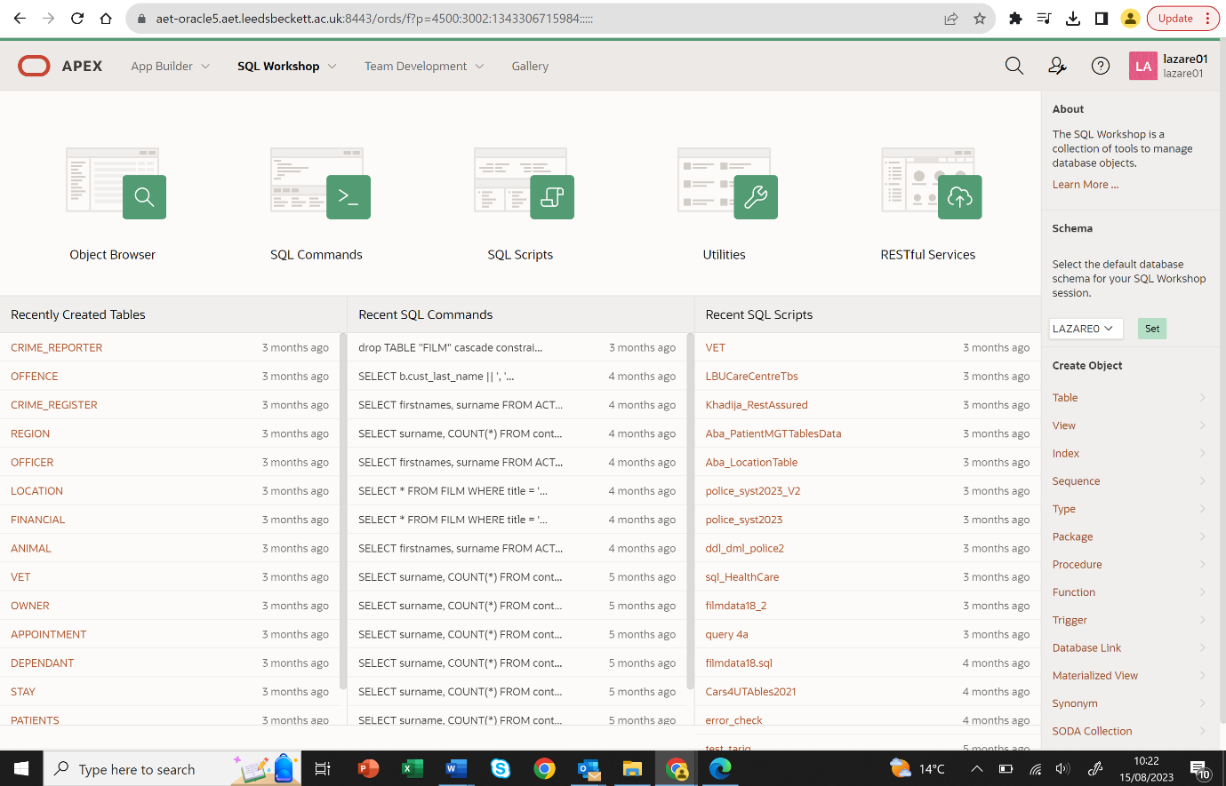
3

Important note: We expect to see all Recent activities in the Apex account. If these are blank or older then expected during the semester run (e.g. no activity or no

Page 4

Task 1: Conceptual Design

Include your Assumptions here
- Each CD is published only by on the publisher
- A band may be published by several companies

1.2 Extended Entity Relationship Diagram (EER Diagram)

Paste here your EERD
(Please make sure that we can see your diagram, easily. Use QSEE to design your EERD)

1.3 List your attributes and identifiers here:
Company (Company_id, Company_Name, Address, Phone, Country…
Cd( cd_id, … , price
….
1.4 Include a list of the Validation Questions of your model here:
- List of CDs and prices
- List all company phone numbers

1.5 A definition for each entity…..
- EntityName: Company hold details on the CD’s publisher
- EntityName:
1.6 Occurrences for each entity...
Company id | Company name | Address | Phone | Country
001 | UTSF | Otley | 0113-111 111 | UK
002 | PJWSTK | Beckett | 0142-222 222 | UK

Task 2: Logical Design
LIST of tables and attributes, defining all Primary Keys and any Foreign Keys(s) derived from the EERD.
Any discussion?
Example:

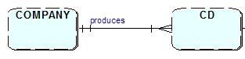
Company (companyid, att1, att2, att3
CD( CD_id, att1, att2, att3, companyid

Etc…
Table2 (pkkey att1, att2, att3
Table3 (pkkey att1, att2, att3,….. fk_key_attribute

Task 3: Physical Design

Check document on physical design, key points that you can bring to this section and discuss as part of this task.

Task 4: Tables implementation

Screenshot of code running successfully.
Each member has to include screenshot of running it in their own Oracle Apex environment, uploaded as part of the group submission.
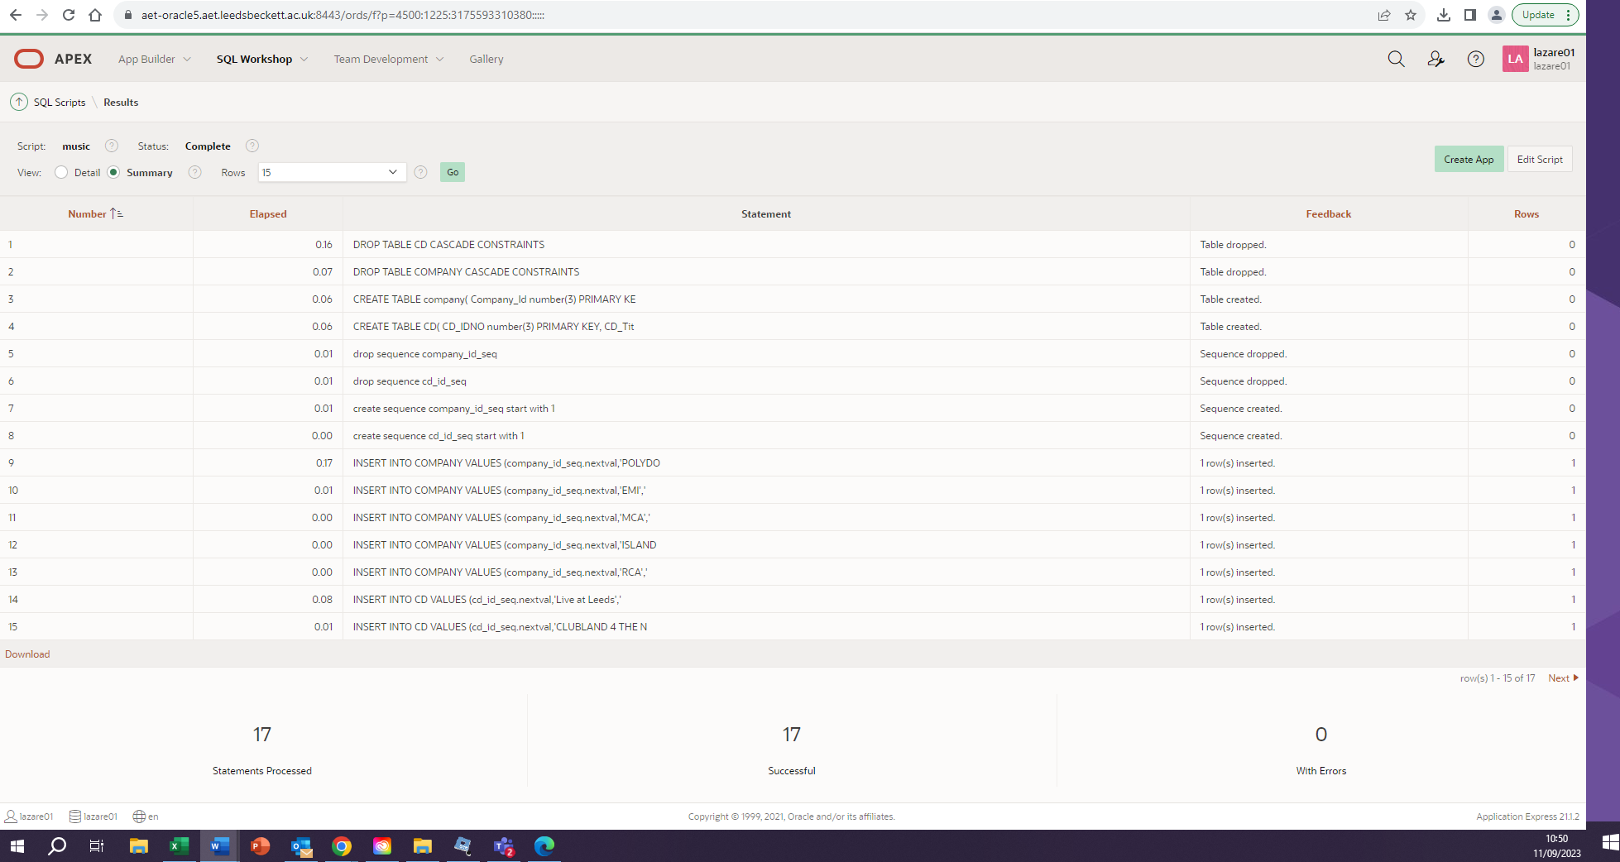
--make sure you run test...
-- evidence screenshots of code running.
-- Also, include scripts code as shown below;

DROP TABLE CD CASCADE CONSTRAINTS;
DROP TABLE COMPANY CASCADE CONSTRAINTS;

CREATE TABLE company(
Company_Id number(3) PRIMARY KEY,
Company_name VARCHAR2 (15) NOT NULL,
Country VARCHAR2 (15) NOT NULL,
Phone_number VARCHAR2 (15) NOT NULL);

CREATE TABLE CD(
CD_IDNO number(3) PRIMARY KEY,
CD_Title varchar2(50) NOT NULL,
CD_Artist varchar2(30) NOT NULL,
CD_Date_Purchased date NOT NULL,
CD_Payment_type varchar2(6) NOT NULL,
CD_Music_category varchar2(10) NOT NULL,
CD_Price number(4,2),
Company_Id number(3) references company(Company_Id));

INSERT INTO COMPANY VALUES (1,'POLYDOR','UK','0171 0989099');
INSERT INTO COMPANY VALUES (2,'EMI','UK','0171 0989088');

INSERT INTO CD VALUES (1,'Live at Leeds','The Who','12/12/12','Cash','Rock',10.99,'1');
INSERT INTO CD VALUES (2,'CLUBLAND 4 THE NIGHT OF YOUR LIFE','VARIOUS','12/12/12','Cash','Club',13.99,'1');
INSERT INTO CD VALUES (3,'CLUBBERS GUIDE 2004','VARIOUS','04/12/12','Credit','Club',13.99,'1');
INSERT INTO CD VALUES (4,'THE VERY BEST OF STING AND THE POLICE','The POLICE','12/12/12','Cash','Rock',10.99,'2');

7. Bibliography

LBU Harvard style

8. Appendixes
If any….

